**BT305 LAB 6**

**Name:** Aditya Jindal

**Roll No.:** 210106004

**MODEL 1 :** Major Cold shock protein from Staphylococcus aureus

Aligning SWISS model and ModWeb model

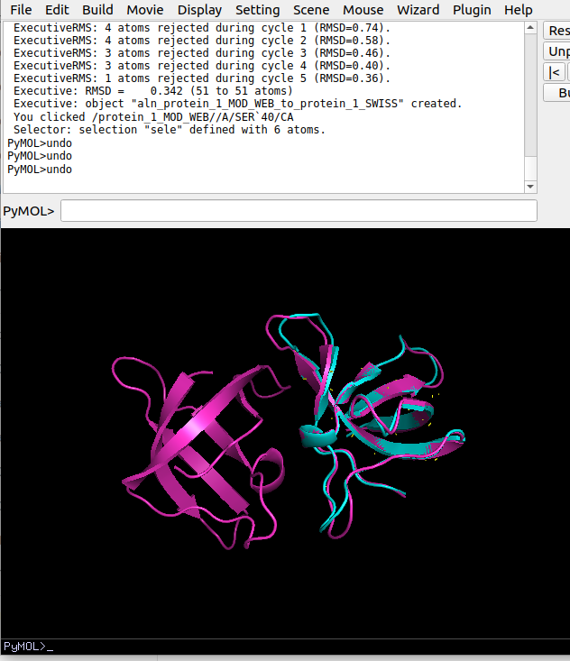RMSD = 0.342

Aligning BLAST homologous model and ModWeb model

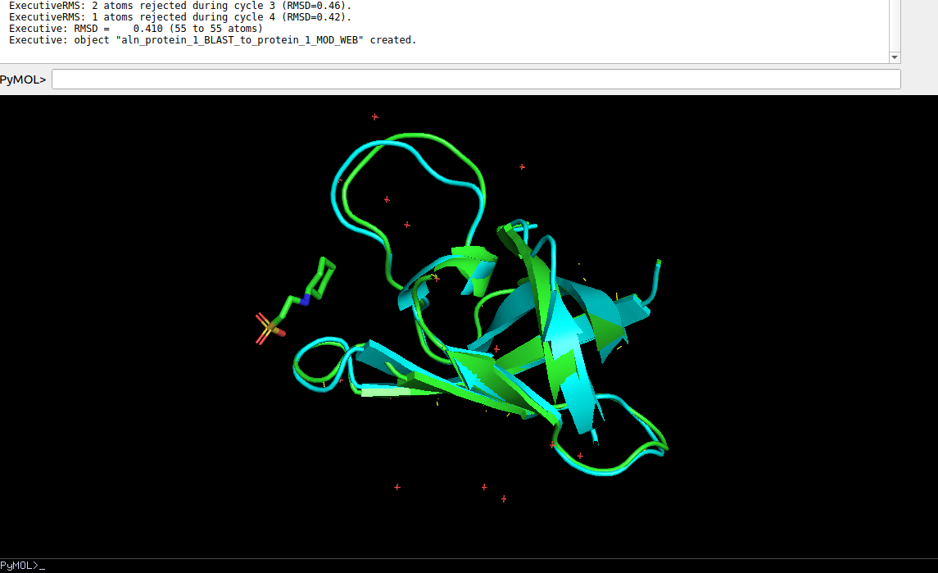

RMSD = 0.410

Aligning BLAST homologous model and SWISS model

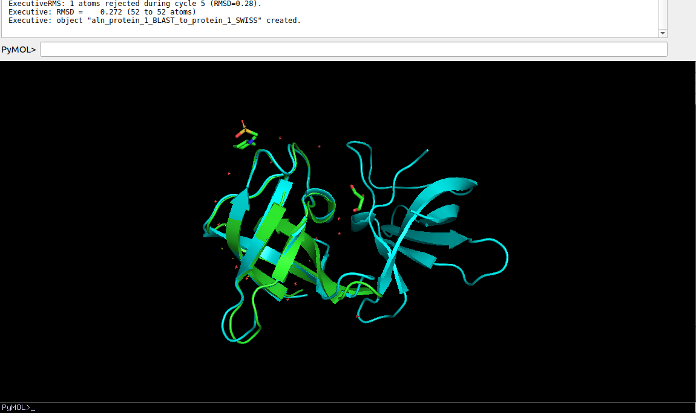

RMSD = 0.272

**MODEL 2 :** Antifreeze protein from Pachycara brachycephalum

Aligning SWISS model and ModWeb model

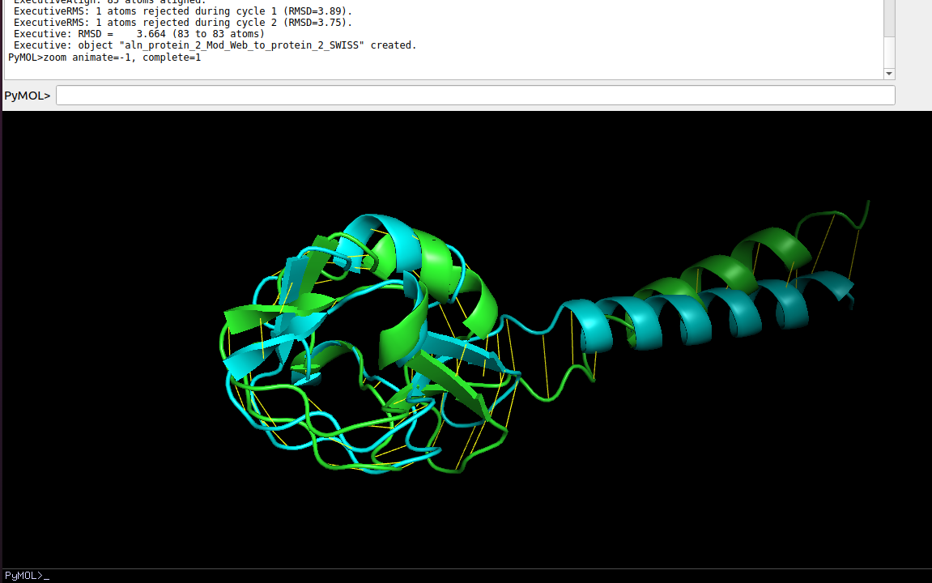

RMSD = 3.664

Aligning BLAST homologous model and ModWeb model

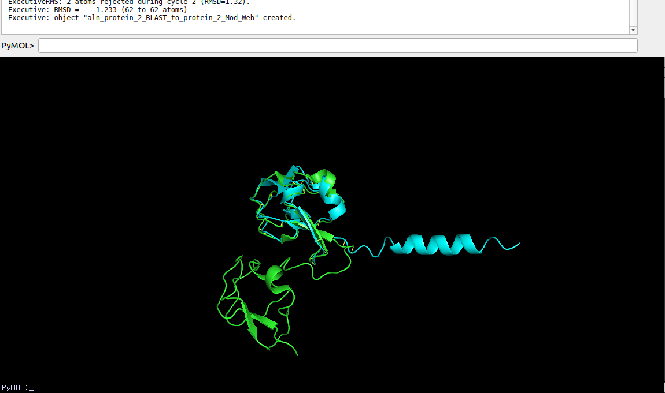

RMSD = 1.233

Aligning BLAST homologous model and SWISS model

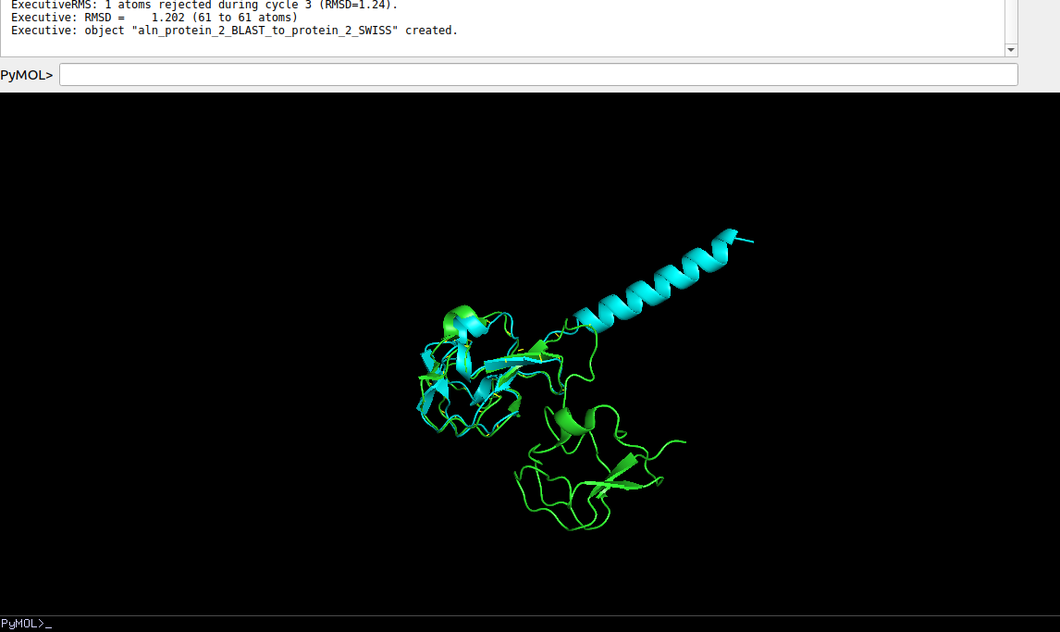

RMSD = 1.202

**MODEL 3 -** Dihydrofolate reductase from Vibrio cholerae

Aligning SWISS model and ModWeb model

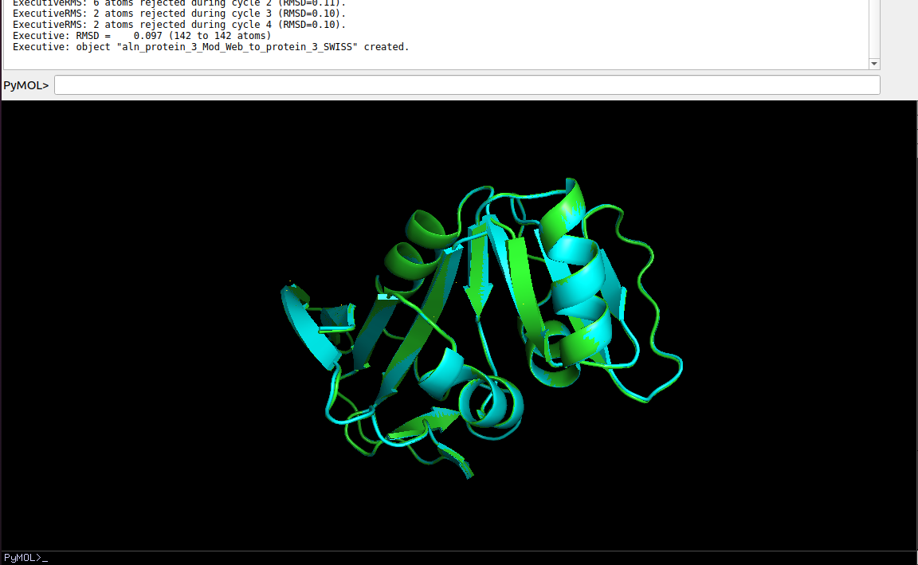

RMSD = 0.097

Aligning BLAST homologous model and ModWeb model

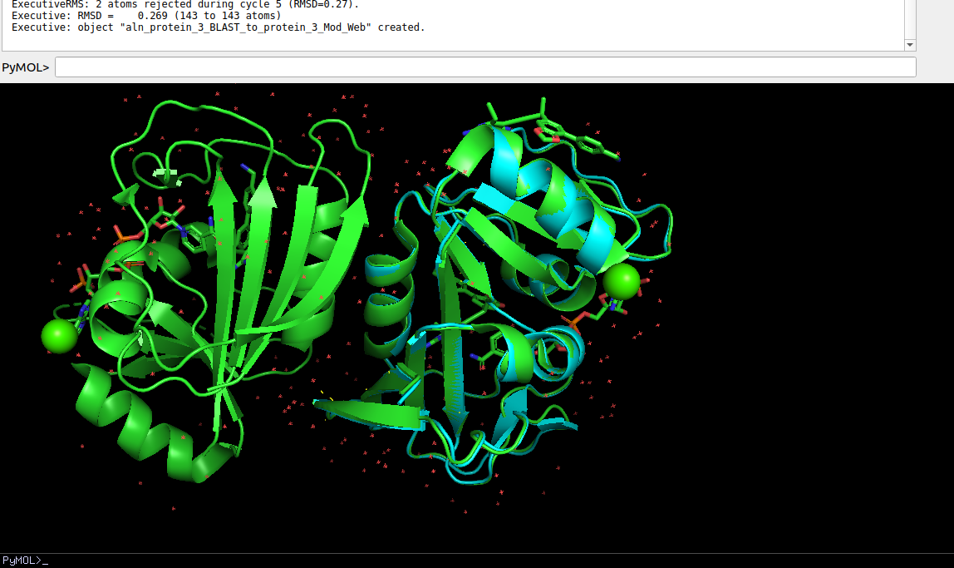 RMSD = 0.269

Aligning BLAST homologous model and SWISS model

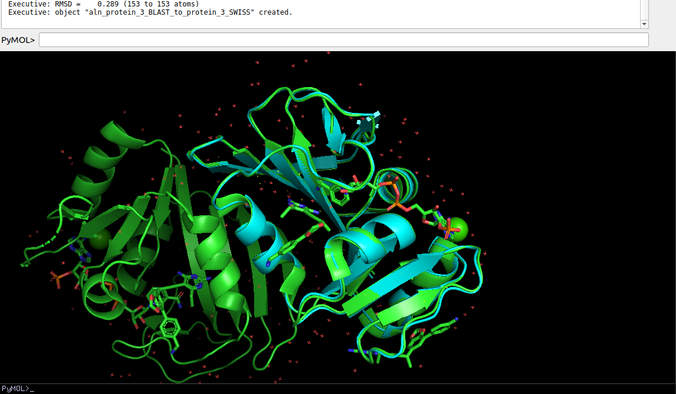 RMSD = 0.289

**VAST Scores:**

**Model 1:**

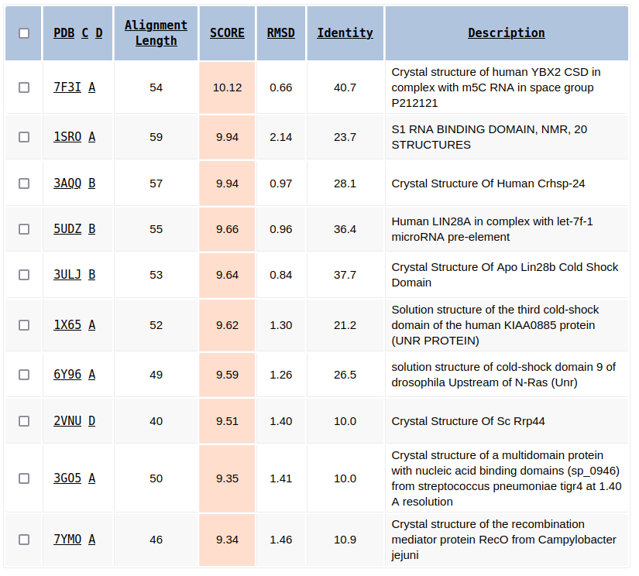

**Model 2:**

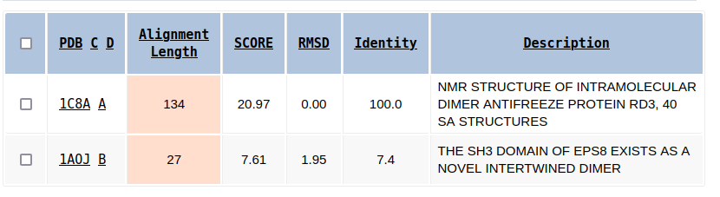

**Model 3:**

